**“FUNDAMENTALS OF PROGRAMMING”**

**HOMETASKS LAB – 04**

**SUBMITTED TO:**

**SIR MUHAMMAD AFFAN**

**SUBMITTED BY:**

MOMINA HAQ

CMS ID: 468932

ME-15 (B)

**TASK 01:**

#include<iostream>

using namespace std;

int main() {

for(int x = 1; x <= 150; x++) {

if(x % 10 == 0) {

continue; // Skip the number if it is a multiple of 10

}

cout << x << " "; // Print the remaining set of numbers

}

return 0;

}

**OUTPUT:**

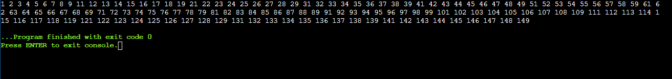

**TASK 02:**

#include <iostream>

using namespace std;

int main()

{int num,r,x,sum=0;

cout<<"Enter the number: ";

cin>>num;

do {

r=num%10; //the remainder after dividing an number with 10 will give its last digit

num=num/10;

sum+=r; //The digit so found is added to the sum

}

while(num!=0); // the loop continues till all digits have been added

cout<<"The sum of digits of the given number is : "<<sum<<endl;

return 0;

}

**OUTPUT:**

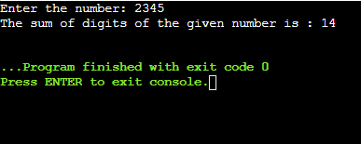

**TASK: 03**

#include <iostream>

using namespace std;

int main()

{

int num,i, x=0 ;

cout<<"Enter the number : ";

cin>>num;

for(i=2;i<=num;i++)

if(num%i==0)

{ x=x+1; //Here the nnumber x keeps track of divisors, each time the loops runs to check the

//divisiblity of num with with tha value of i , the values of x are also changed accordingly.

}

if (x==1) //After all the numbers are check for their divisibilty , if the final value of x is 1 it

//means that the number is only divisible by one number , that is itself and hence is prime.

{

cout<<"The given number is prime"<<endl;

}

else{

cout<<"The given number is not prime"<<endl;

}

return 0;

}

**OUTPUT:**

